Protocol # | Description | Purpose | Reqt/Spec
  Author
Emp004 | Update User | To verify  1.Able to update the user record.  2. Update functionality of mandatory fields.

Prerequisites | - Standard System Configuration  - User must be logged In to the web interface.  - The user must have Local and system admin privileges.  - At least one employee should be available for the selected location.  - At least one group should be available for the selected location.
Procedure | - Login to the web interface.  - Click on Administration link from the top right menu.  - Click on Users link  ER 1 – User records Screen is displayed.  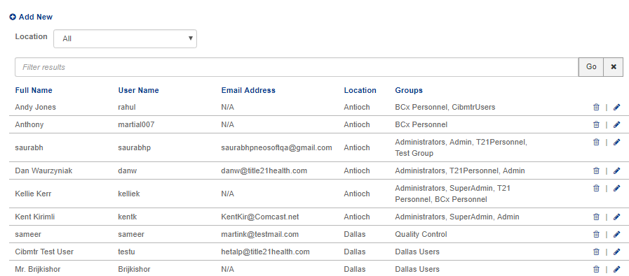  - Click on location drop-down and select the specific location (for eg. Dallas).  ER 2 – Only users of selected location are displayed.  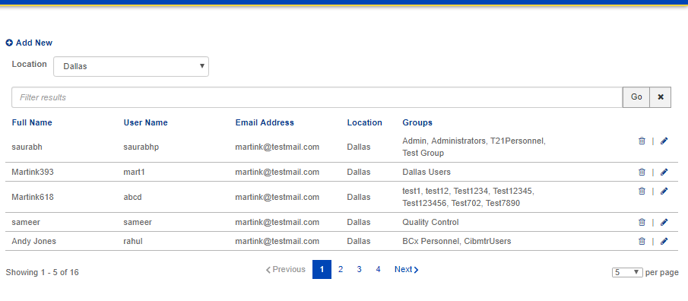  - Click on search filter and enter the user’s name  - Click on Go button  ER 3 – User Record as per search is displayed.  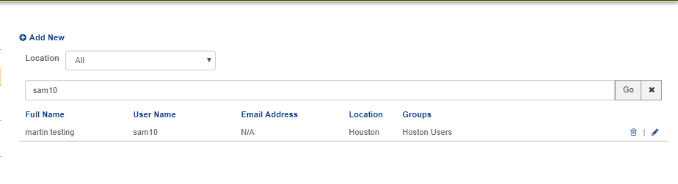  - Click on Edit Button  ER 4- Update user screen is displayed.  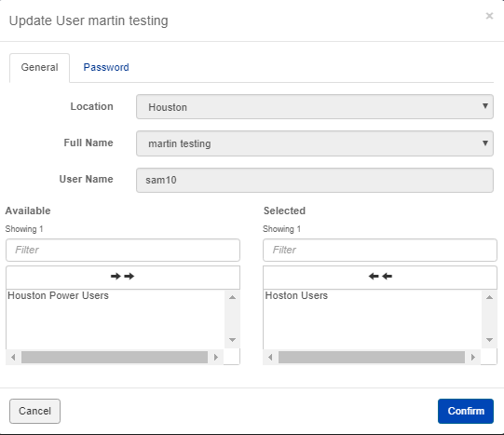  ER 5- location, full name, and username field are disabled.  - Add one group  - Click on confirm  ER 6 – A message confirming successful update is displayed.  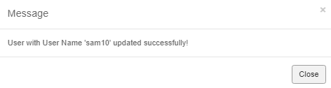  - Click on close button  - Again click on edit button.  - Check the edit password checkbox.  ER 7 – The new password and confirm password field should get enabled.  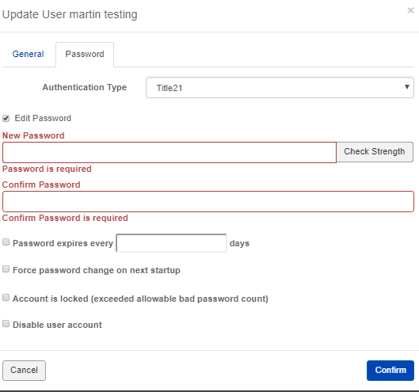  - Enter password and confirm password  - Click on confirm  - Logout from admin  - Login with that user using updated password  ER 8 – User should able to login with new password.  - Logout from user.  - Login as admin user.  - Click on Administration link from the top right menu.  - Click on user link.  - Search for the user.  - Again edit user.  - Go to password tab.  - Enter password and confirm password.  - Click on cancel.  - Logout from admin.  - Try to Login with that user and with updated password.  ER 9 – Password and confirm password are unchanged.  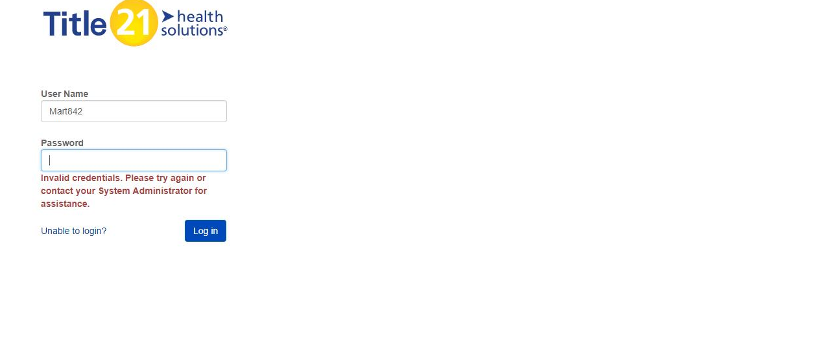
Pass/Fail | Pass:  Fail: | Type of Execution |  | Date:
Pass/Fail | Pass:  Fail: | Automation: | Manual: | Date:
 | Date of Execution:
Notes/Deviations
Additional Remarks in case of Manual Execution
Name of Tester(if Manual)
Test Case Review/Approval | Signature of  Reviewer/Approver: |  |  | Date of Approval:

